**DC 12V 24V 36V 15A 500W Brushless Motor Controller Hall BLDC Driver Board New**

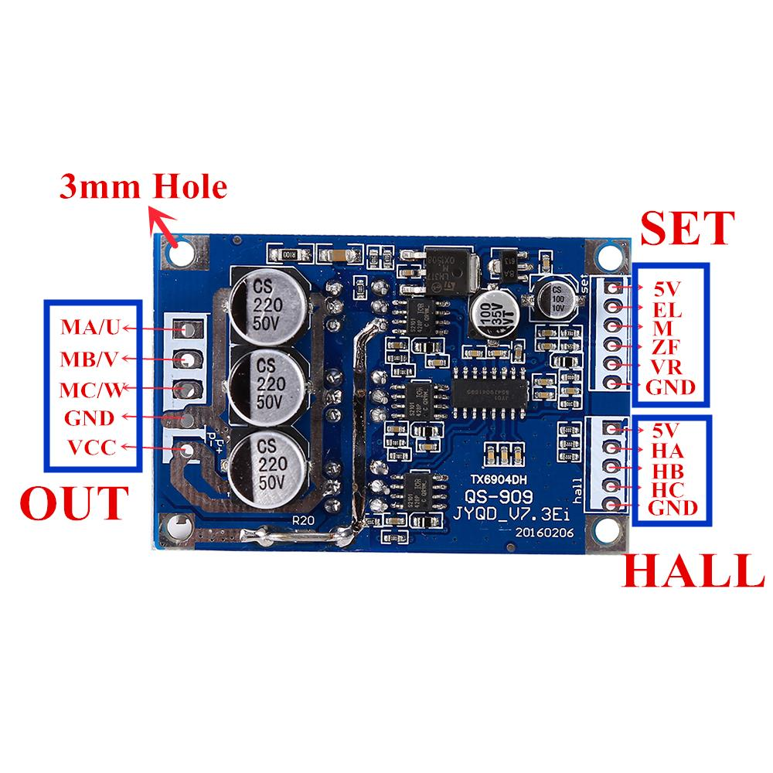

**Description:**

100 Brand New & High Quality

**Specification:**

Operating voltage: DC 12V-36V

Operating Current: <=15A

Driver Power: <=500W

Speed Voltage: 0.1V-5V

Operating Temperature:-40-85°C

Humidity: 90%RH

Stall protection:Yes

Enable Control: Yes

Over-current protection: Yes

Steering control: Yes

Speed control signal: Yes

Size: 63*42*17mm(L*W*H); Probe size 3mm,length: fixing hole center distance 57mm; width:fixed hole center distance 36.5mm

**Power terminal Out:**

* VCC(positive power supply)
* GND(negative one)
* MC(motor phases W)
* MB(motor phases V)
* MA(motor phase U)

**Set for the control side:**

* **[GND]** control terminal ground
* **[VR]** the governor end 0-5V(corresponding to 10% of motor speed -100%)
* **[ZF]** reversing control(connected to 5V or ground can charge the motor rotation direction)
* **[M]** tachometer pulse output(depending on the number of motor poles corresponding to the number of pulse per revolution of the output number)
* **[EL]** enable control terminal(connected to 5V ot ground running then 5V, grounding the motor stops)
* **[5V]** 5V control terminal

**HALL for the hall terminals:**

* **[5V]** Hall power positive
* **[Ha]** Hall signal
* **[Hb]** Hall signal
* **[Hc]** Hall Signal
* **[GND]** Hall negative

**Wiring:**

**Control terminal for SET:**

1. The motor speed control wiring methods: available potentiometer system speed can also be connected to the MCU control, when the potentiometer control wiring, the potentiometer middle pin is connected to VR speed port, potentiometer connected to both ends of 5V and GND terminal voltage more high speed faster.

2. Motor steering control wiring methods： you can switch control can also be connected to the MCU control, to GND in one direction, then in one direction 5V.

3. Pulse speed signal: high and low output . IC can not understand the information with the customer request.

**Hall signal inputs for hall:**

Wiring diagram is shown, one corresponding to the HA, HB,HC and on the motor, 5V power supply connected to the motor hal signals positive, GND power supply negative signal to the motor hall.

**Note:** Due to different motor manufacturers to make the hall of hall line order does not necessarily follow the line on the board to match the sequence, need to be adjusted, please parents who pay attention! If the line sequence wrong, does not boot properly, current, or start other phenomena not open, forced to use the drive plate will burn!!!

Motor driver board 12-36V DC power input , VCC positive power supply,GND power supply is negative.

Electrical wiring methods: Brushless DC motor for the three lines, corresponding MA/U,MB/V,MC/W

**Tips:**

If you use less than 60W, without additional heat sink , be sure to add more than 60W

heatsink fins drive efficiency without lowering the temperature is too high will shine into permanent damage! The size of the heat sink may be a bad environment based work(recommended cooling surface area greater than 200 square centimeters)!When installing the heat sink ,must pay attention to the back of the module 6 MOS pipe insulation, no insulation, it will be adhered to drive plate permanently damaged! Proposes to add insulation films, both sides of the insulating sheet plus thermal grease!